

FOR IMMEDIATE RELEASE
October 20, 2025
MEDIA CONTACT
Melissa Dupuis
mdupuis@troon.com

Team Baylor Takes a One-Stroke Lead over Santa Clara

Li and Narita T1 at 67 after firing an impressive 5-under par today

[Līhu‘e, Kaua‘i] — Team Baylor holds a narrow one-stroke lead over Santa Clara University after the opening round of the 2025 Rainbow Wahine Invitational, played on the award-winning Ocean Course at Hōkūala.

Baylor was led by Yurang Li, Malena Castro (T3) and Silje Ohma (T6), all of whom finished under par on the Jack Nicklaus Signature layout. Individual Baylor player Charlotte Brooke (T3) also fired a 4-under-par 68, which shows the strength of the Bear’s bench this season.

Li, a third-year player and Illinois transfer, recently captured the Canadian Women’s Amateur Championship, earning an exemption into the Canadian Women’s Open. She carded four birdies, an eagle, and just one bogey en route to a 5-under par 67. Ranked No. 206 nationally, Li heads into the second round tied for the individual lead with San Diego State’s Ema Narita.

Baylor head coach Jay Goble noted that the team has undergone a significant roster refresh this season. “We have a whole half of a new team, but I (was) excited to get some new players in,” Goble said. “Every year brings some different challenges and personalities, but I’m really enjoying this group.” The Bears will begin the second round one shot ahead of Santa Clara.

Narita, a third-year Aztec, posted a new collegiate career low with her 5-under par 67, eclipsing her previous best of 69. She recorded seven birdies on the day and was the only San Diego State player to finish under par. Starting on the back nine proved advantageous, as she avoided the stronger trade winds that picked up later along Hōkūala’s oceanfront holes.

Rounding out the early contenders, Kaitlyn Helm, a freshman at Washington State, shares third place after carding a 4-under par 68 highlighted by four birdies on the front nine. Helm, who recently finished third at the Badger Invitational, continues to make an impression in her first collegiate season.

Team Santa Clara was led today by Proud Sriwongngam, who at one point held the lead but slipped back on her second to last hole. Sriwongngam and fellow teammate finished at 3-under, along with Alexa Pinede at 2-under. The Broncos are just one stroke off the Bears and with 36 holes to play, it is still anybody’s game.

Tournament attendance is free for walking spectators. Parking is available on-site. The Ocean Course at Hōkūala is a five-minute drive from Lihue Airport (LIH).

TOURNAMENT FACTS
Dates: October 20–22, 2025
Venue: Ocean Course at Hōkūala
Location: Lihu‘e, Kaua‘i
Yardage (Par): 5,929 (72)
Format: 54 holes; 18 holes each day; 5-count-4
Tee Times: 9:30 a.m. HT Monday and Tuesday; 9:00 a.m. HT Wednesday
Live Scoring: SCOREBOARD

Host: Hawai‘i
2024 Champion: Colorado State (841; -23)
2024 Individual Champion: Lacey Uchida, Colorado State (204; -12)

TEAMS (19)
Baylor, Boise State, BYU, Eastern Michigan, Grand Canyon, Hawai‘i, Idaho, Kansas, Kennesaw State, Long Beach State, Missouri, Nevada, Osaka Gakuin (Japan), Sacramento State, San Diego State, Santa Clara, Tulane, Washington State and Wyoming.

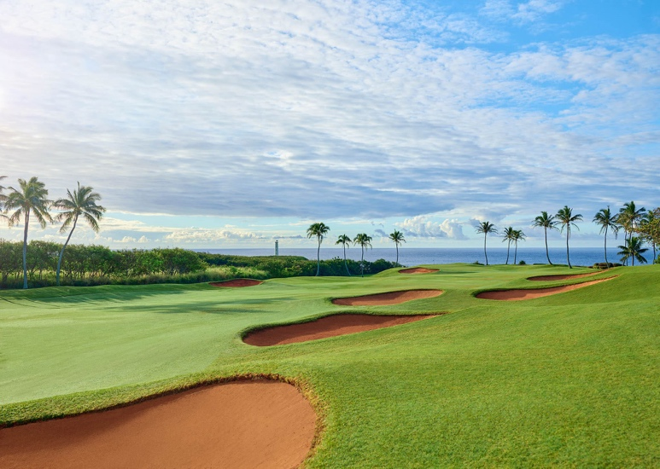
The tranquil par 4 13th on the Ocean Course at Hōkūala finishes at the iconic Ninini Point Lighthouse. (Photo by Ocean Course at Hōkūala)

###

About Ocean Course at Hōkūala
Home to the longest continuous stretch of oceanfront holes in the state of Hawai‘i, the Ocean Course was named one of the “World’s Most Beautiful Golf Courses” by MSN Travel. The 18-hole golf course is part of Timbers Kaua‘i Ocean Club & Residences, a private residential club which opened in 2018 on the island’s southeast coast. Timbers Kaua‘i sits on a 450-acre natural amphitheater and offers unobstructed views of the Pacific Ocean, Kalapaki Bay and Hā‘upu Mountain Range. Website | Facebook | Instagram

About Troon
The Ocean Course at Hōkūala is managed by Indigo Sports, a Troon company. Headquartered in Scottsdale, Ariz., Troon is the world’s largest golf and golf-related hospitality management company providing services at 950-plus locations in 45-plus states and 40-plus countries, including operational responsibility for 575-plus 18-hole equivalent golf courses. In addition to golf, Troon specializes in homeowner association management, private residence clubs, estate management and associated hospitality venues. Troon’s award-winning food and beverage division operates and manages 600-plus food and beverage operations located at golf resorts, private clubs, daily fee golf courses and recreational facilities. Troon’s family of brands includes Troon Golf, Troon Privé, Troon International, Indigo Sports, CADDIEMASTER, ClubUp, Cliff Drysdale Tennis, Peter Burwash International, True Club Solutions, RealFood Hospitality, Strategy and Design, Casa Verde Golf, ICON Management and Eventive Sports. For additional news and information, visit www.Troon.com, TroonMagazine.com or connect with Troon on Facebook, X, and Instagram.

