

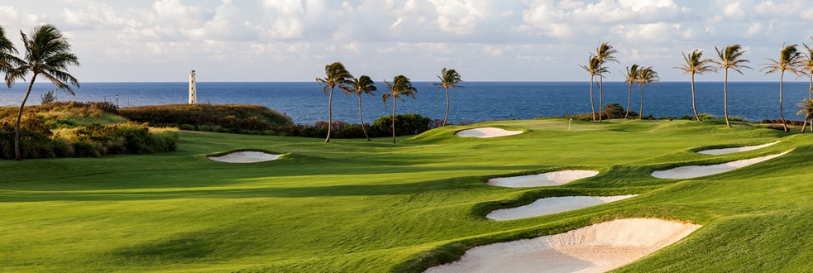

FOR IMMEDIATE RELEASE
October 16, 2025
MEDIA CONTACT
Pate Clarson
pclarson@golfhokuala.com

Kaua‘i and Hōkūala to host celebrated women’s event next week

2025 Rainbow Wahine Invitational moves to Kaua‘i after 25 years on O‘ahu

TOURNAMENT FACTS
Dates: October 20–22, 2025
Venue: Ocean Course at Hōkūala
Location: Lihu‘e, Kaua‘i
Yardage (Par): 5,929 (72)
Format: 54 holes; 18 holes each day; 5-count-4
Tee Times: 9:30 a.m. HT Monday and Tuesday; 9:00 a.m. HT Wednesday
Live Scoring: SCOREBOARD

Host: Hawai‘i
Defending Team Champion: Colorado State (841; -23)
Defending Individual Champion: Lacey Uchida, Colorado State (204; -12)

TEEING OFF
The 2025 edition of the University of Hawai‘i’s storied women’s golf tournament – the Rainbow Wahine Invitational – will be held on the Ocean Course at Hōkūala on Kaua‘i, showcasing another Troon-managed Hawai‘i club after being held last year at Kapolei Golf Club on O‘ahu. From Oct. 20 – 22, 19 teams from 13 states and one from Japan will compete on Hawai‘i’s “Garden Isle.”

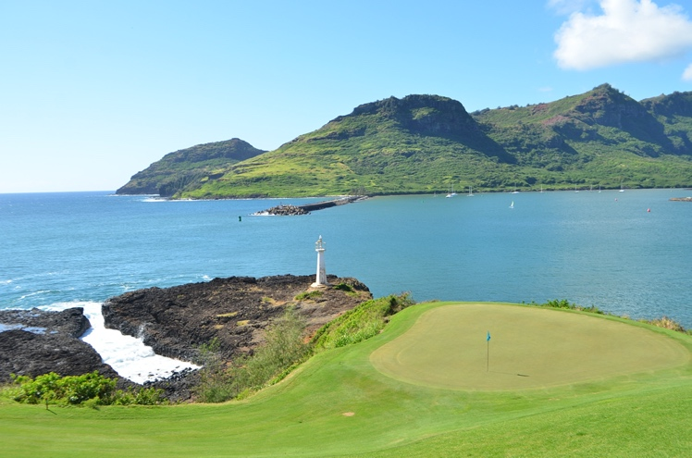
The 16th green on the Ocean Course at Hōkūala is framed by Kalapaki Bay and the Hā‘upu Mountain Range. (Photo by Ocean Course at Hōkūala)

TEAMS (19)
Baylor, Boise State, BYU, Eastern Michigan, Grand Canyon, Hawai‘i, Idaho, Kansas, Kennesaw State, Long Beach State, Missouri, Nevada, Osaka Gakuin (Japan), Sacramento State, San Diego State, Santa Clara, Tulane, Washington State and Washington.

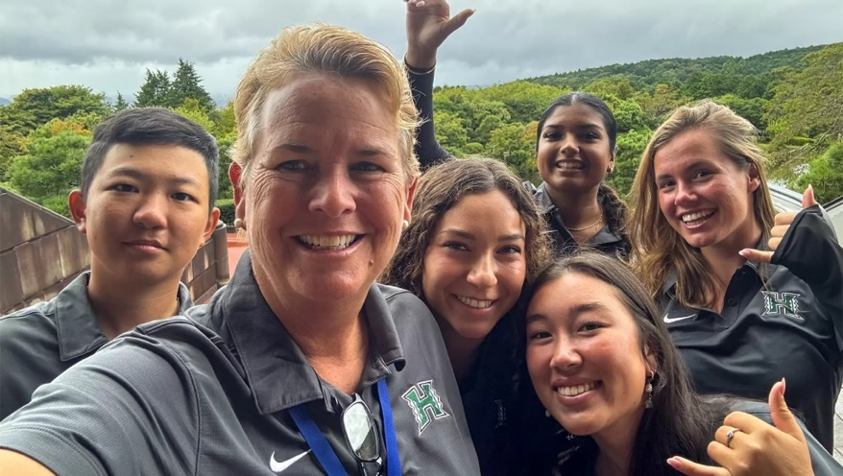
University of Hawai‘i women’s golf coach, Julie Brooks, poses with her players after a recent tournament for a group photo. (Photo by Hawai‘i Athletics)

This spring, the Washington Huskies won the 2025 Dr. Donnis Invitational at Kā‘anapali over two-time tournament champions, Sacramento State.

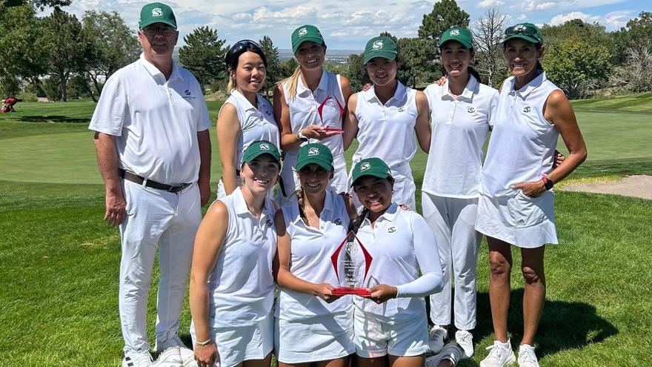
Sacramento State smiles after winning the Dick McGuire Invitational on Sept. 9, 2025, on the University of New Mexico Championship Golf Course in Albuquerque, New Mexico. (Photo by Sacramento State Athletics)

The Sacramento State Hornets will also fly high to Kaua‘i after capturing last month’s Dick McGuire Invitational (Albuquerque, New Mexico).

After Hawai‘i traveled last month to compete in Mishima City, Japan, Osaka Gakuin will make the 8-hour flight across the Pacific Ocean to compete in the Aloha State. They are the only non-U.S. university in this year’s Rainbow Wahine field.

German native and University of Virginia transfer, Maline Kraus, will look to lead the Hawai‘i Rainbow Wahine after being UH’s top finisher at the season-opening Pan Pacific Super League in September in Japan. She tied for 12th place overall with an even par 142.

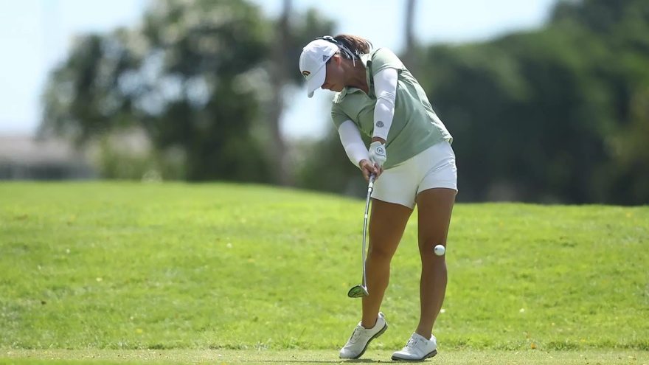
Hawaiʻi senior Maline Kraus tees off during the Pan Pacific Super League in Japan. (Photo by Hawaiʻi Athletics)

VENUE
The Ocean Course at Hōkūala is part of Timbers Kaua‘i, a picturesque 450-acre resort property surrounded by the Pacific Ocean, Kalapaki Bay and Hā‘upu Mountain Range.

The Ocean Course at Hōkūala also played host to another UH-sponsored tournament in 2024, the Dr. Donnis Thompson Invitational.

EVENT HISTORY
Originally created as the Princeville Rainbow Wahine Fall Classic, and later known as the Rainbow Wahine Invitational as the event moved islands and golf courses, UH’s annual fall event has hosted impressive teams and individuals during its 28-year history. UCLA leads all programs with five team titles, followed by Sacramento State (3), Baylor (2), Colorado State (2), Florida International (2) and San Francisco (2). Colorado State is the defending champion.

QUOTES
“There’s a special spirit of Aloha that makes this tournament unique,” said Hawai‘i Women’s Golf Head Coach and three-time Big West Coach of the Year, Julie Brooks. “Hosting on the Ocean Course means the world to me. It’s located in such a beautiful spot on the island, and represents a great opportunity to showcase both the course and island of Kaua‘i.”

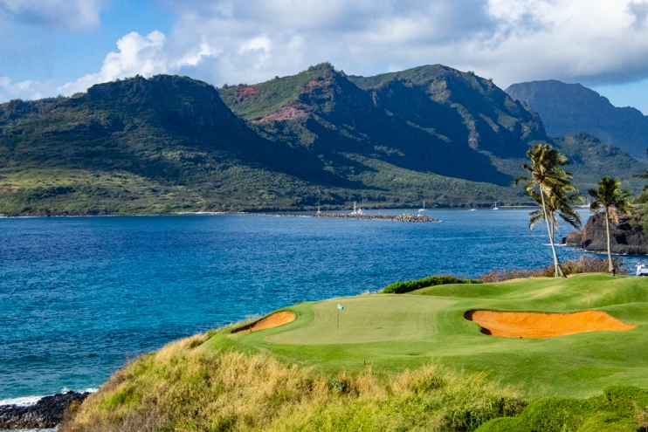
The par 3 14th green on the Ocean Course at Hōkūala is framed by Kalapaki Bay and the Hā‘upu Mountain Range. (Photo by Ocean Course at Hōkūala)

“The heart and soul of our property is based on two main aspects: player development and competition,” said Cort Walter, PGA Head Golf Professional at the Ocean Course at Hōkūala. “Bringing world-class competition allows us to showcase our golf course at the highest levels. We are honored to help create memories for these athletes, families and fans that will last a lifetime.”

FREE CLINIC: SATURDAY
On Saturday at 3:00 p.m. at Hōkūala’s practice facility, a free golf clinic and Q&A will be led by Coach Brooks, the Rainbow Wahine golf team and Kellie Hines, PGA Director of Instruction, Ocean Course at Hōkūala. All keiki aged 3 to 18 are welcome. Free rental clubs will be available.

E ALA E: SUNDAY
On Sunday at 6:30 a.m. prior to the tournament practice round, players, coaches and spectators are welcome to join at the club for a traditional Hawaiian E Ala E ceremony. Taking place on the 13th green, participants will clear their minds and body, letting go of the old and setting a clear intention for the day. Interested parties can meet on the 13th hole tee box at 6:30 a.m. Parking is available in the temporary pro shop lot adjacent to the tee box.

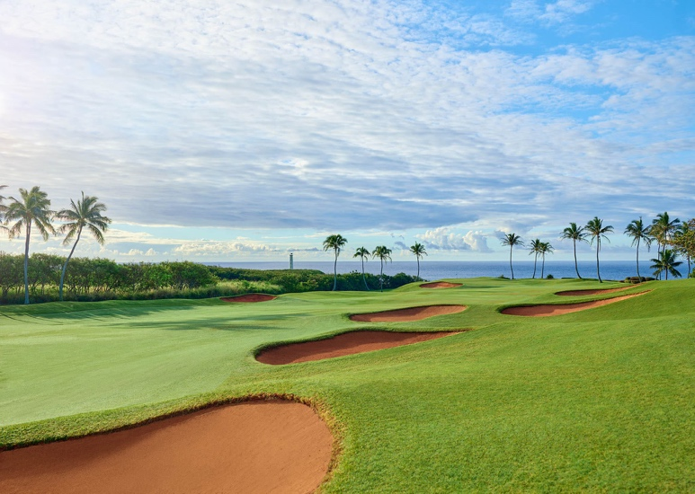
The tranquil par 4 13th on the Ocean Course at Hōkūala finishes at the iconic Ninini Point Lighthouse. (Photo by Ocean Course at Hōkūala)

ATTENDANCE: SUNDAY – WEDNESDAY
Practice round and tournament attendance is free for walking spectators. Parking is available on-site. The Ocean Course at Hōkūala is a five-minute drive from Lihue Airport (LIH).

###

About Ocean Course at Hōkūala
Home to the longest continuous stretch of oceanfront holes in the state of Hawai‘i, the Ocean Course was named one of the “World’s Most Beautiful Golf Courses” by MSN Travel. The 18-hole golf course is part of Timbers Kaua‘i Ocean Club & Residences, a private residential club which opened in 2018 on the island’s southeast coast. Timbers Kaua‘i sits on a 450-acre natural amphitheater and offers unobstructed views of the Pacific Ocean, Kalapaki Bay and Hā‘upu Mountain Range. Website | Facebook | Instagram

About Troon
The Ocean Course at Hōkūala is managed by Indigo Sports, a Troon company. Headquartered in Scottsdale, Ariz., Troon is the world’s largest golf and golf-related hospitality management company providing services at 950-plus locations in 45-plus states and 40-plus countries, including operational responsibility for 575-plus 18-hole equivalent golf courses. In addition to golf, Troon specializes in homeowner association management, private residence clubs, estate management and associated hospitality venues. Troon’s award-winning food and beverage division operates and manages 600-plus food and beverage operations located at golf resorts, private clubs, daily fee golf courses and recreational facilities. Troon’s family of brands includes Troon Golf, Troon Privé, Troon International, Indigo Sports, CADDIEMASTER, ClubUp, Cliff Drysdale Tennis, Peter Burwash International, True Club Solutions, RealFood Hospitality, Strategy and Design, Casa Verde Golf, ICON Management and Eventive Sports. For additional news and information, visit www.Troon.com, TroonMagazine.com or connect with Troon on Facebook, X, and Instagram.

